**Med D Update: Enrollment Support Task from Member Search**

**Description:** An update has been made to the Med D Member Search. This is part of the August 2025 Software Release and is effective as of **08/22/2025**.

If a CCR is unable to locate a beneficiary in the system and needs to create a **Med D Enrollment** Support Task, the option has been moved from the **Search by Member** tab to the **Search by Medicare D** tab.

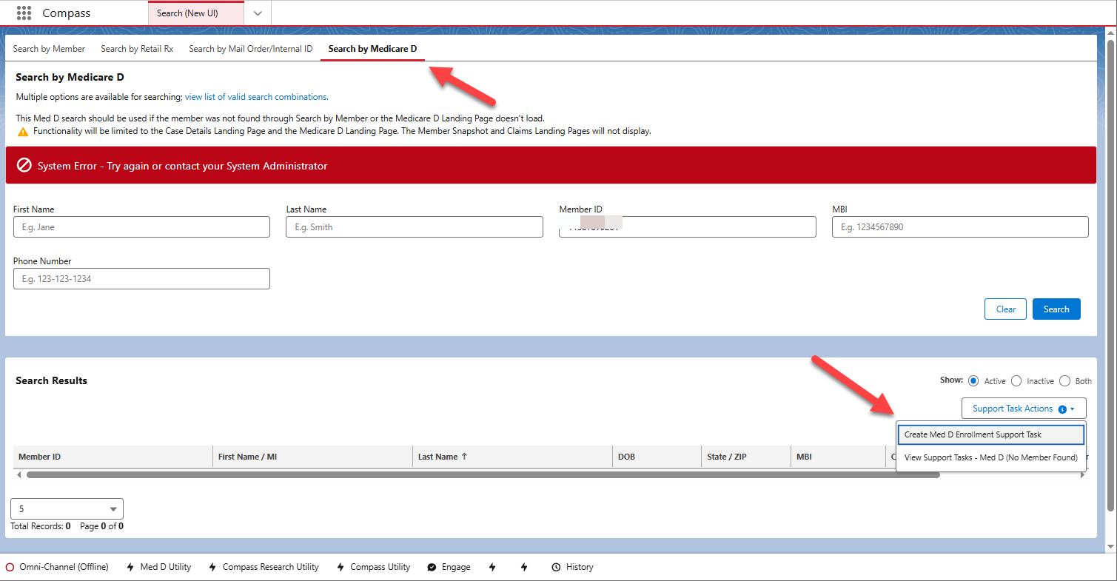

Refer to [Compass MED D - Creating a Med D Enrollment Support Task from Member Search](https://thesource.cvshealth.com/nuxeo/thesource/#!/view?docid=8f0ee5f0-c1ec-45b4-961e-f58567a90e21) for more information.

Top of the Document

Not To Be Reproduced Or Disclosed to Others Without Prior Written Approval

**ELECTRONIC DATA = OFFICIAL VERSION / PAPER COPY – INFORMATIONAL ONLY**